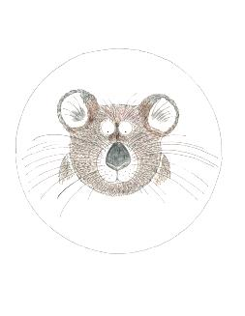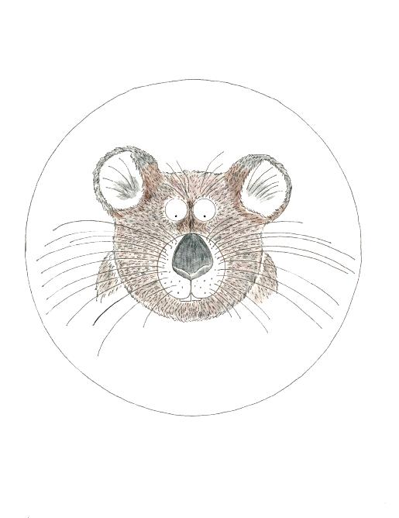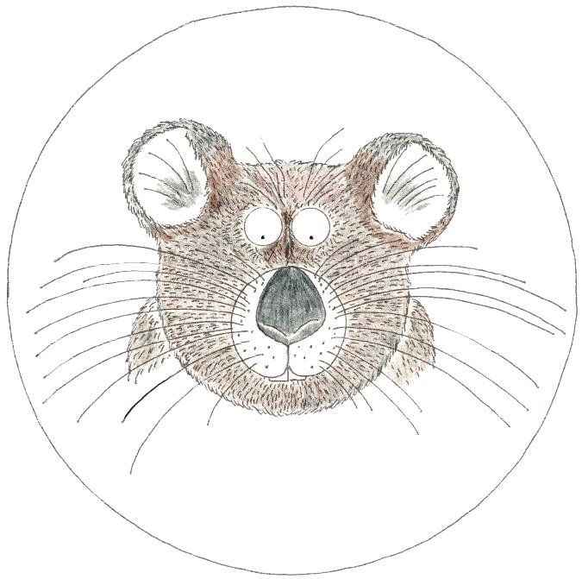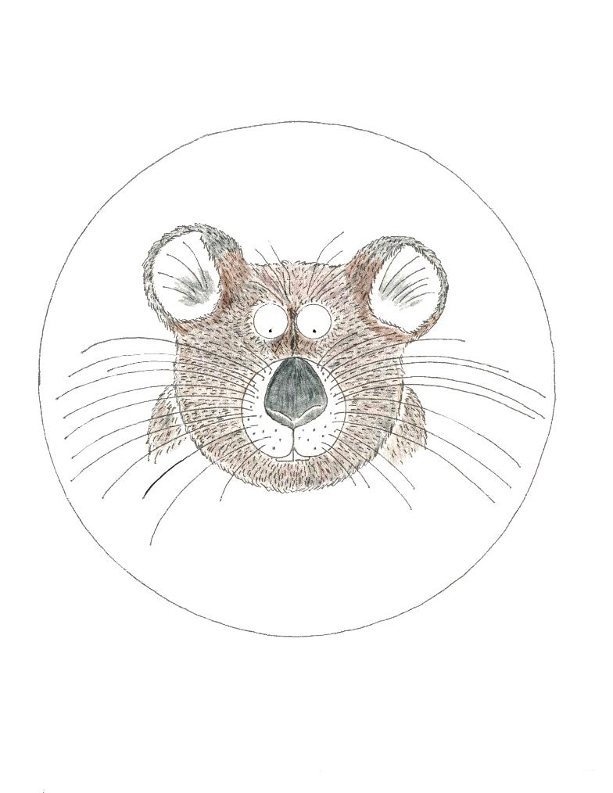

This document includes 30 total pikas: 10 large, 10 medium, and 10 small. This is sufficient for one pika natural selection kit for a single student group. (See lesson plan)

