GRADES: 6-8

DESCRIPTION
Students analyze camera trap images to determine the type of scientific data that can be gathered from these images (i.e., species identification, habitat) and discuss the role and value of this data for scientific research.
KEY QUESTIONS:
- What types of data can be found in camera trap images?
- What role do data play in scientific research?

LEARNING GOALS:
After completing this activity, students will be able to:
- Understand what data are and the variety of data collection methods
- Describe the role of data in scientific investigation
- Analyze the pros/cons of different types of data and data collection methods

TIME: 30 minutes

MATERIALS:
- Paper
- Pens/pencils
- White/blackboard or large format paper
- Access to http://emammal.si.edu in small groups

Next Generation Science Standards* Addressed:
*GSS Lead States. 2013. Appendix H: Understanding the Scientific Enterprise: The Nature of Science in the Next Generation Science Standards. Next Generation Science Standards: For States, By States. Washington, DC: The National Academies Press.
Middle School: Scientific Investigations Use a Variety of Methods
- Science investigations use a variety of methods and tools to make measurements and observations.
- Science investigations are guided by a set of values to ensure accuracy of measurements, observations, and objectivity of findings.
- Science depends on evaluating proposed explanations.
- Scientific values function as criteria in distinguishing between science and non-science.

Middle School: Scientific Knowledge is Based on Empirical Evidence
- Science knowledge is based upon logical and conceptual connections between evidence and explanations.
- Science disciplines share common rules of obtaining and evaluating empirical evidence.
THE LESSON:

BACKGROUND: The Scientific Process and Key Terms
The science around camera trapping is like any other science – it originates with a question about the natural world, and proceeds through a series of steps to answer that question. For a full account of how scientists at the Smithsonian Institution conduct ecological studies using camera traps, please see the “Summary of Camera Trapping Science Procedures” file. For the purposes of this lesson, students should be familiar with the following portions of the scientific process:

Observation
Humans observe the world around them every day. Students might have noticed in their schoolyard or neighborhood that a neighborhood squirrel lives in an oak tree. Scientists also observe their surroundings, but an observation by a scientist is recorded in some way, usually in a field notebook or on a data sheet by a camera or instrument, allowing the scientist to quantify their observations. An observation noting a squirrel’s use of oak trees might lead to an inference about squirrel habitat selection.

Inference and Opinion
An inference is a conclusion reached based on evidence (observations) and reasoning. For example, we may infer a relationship between squirrels and oak trees based on an observation in a schoolyard or neighborhood. Inference is something the human brain does all the time, but we must be careful of inferring too much from limited observations. Inference without data to support it is an opinion.

Data
We call the verifiable, quantitative information we use to answer questions data. Scientists collect data using specific protocols that they develop for their own or developed by the science community, so that the data is standardized and easily repeatable and comparable. There are particular qualities of data we look for to make sure it is capable of answering our questions. Data must be:
- from a reliable source or direct measurement
- relevant to the topic
- appropriately collected
- of sufficient number and repeatability (i.e. documentation on method) to answer the question.

Correlation, Causation, and Experiments
Even if we follow all the rules above when collecting data, we need to be careful of how we interpret those results. Data analysis involves testing our observations using mathematical formulas. If we find a pattern, do we know what caused it? It is important to distinguish between seeing a pattern between two variables (e.g. squirrel presence and tree type), which is a correlation and inferring causation (e.g. that squirrels live in oak trees because they eat their acorns). The leap from a correlation (squirrels in oaks) to a conclusion about causation (acorns attract squirrels) often involves inferring beyond what our data directly show us. Inference can quickly turn into speculation, and once inferences are becoming too separated from the data, we may need to return to more data collection, often in the form of a hypothesis with alternative ideas that can be tested with an experiment or additional data. In this example, we might design an experiment to see if squirrels continue to use oak trees if the acorns are removed.

STEP 1: Brainstorm “data” in small groups (5 minutes)

- If your class has not previously discussed the concepts in “Background,” take a few minutes to provide an overview of those scientific principles.

- Students should keep these concepts in mind throughout these activities as they explore different data types, collect data, and use that data to answer scientific questions and better understand the ecology of Virginia.

STEP 2: Have students look for data in the camera trap images. (15 minutes)
- Explain to students what camera trap images are and how they are a particular type of data that scientists use. (Review Camera Trapping Overview file, found in the eMammal curriculum supplemental materials, for more information.)

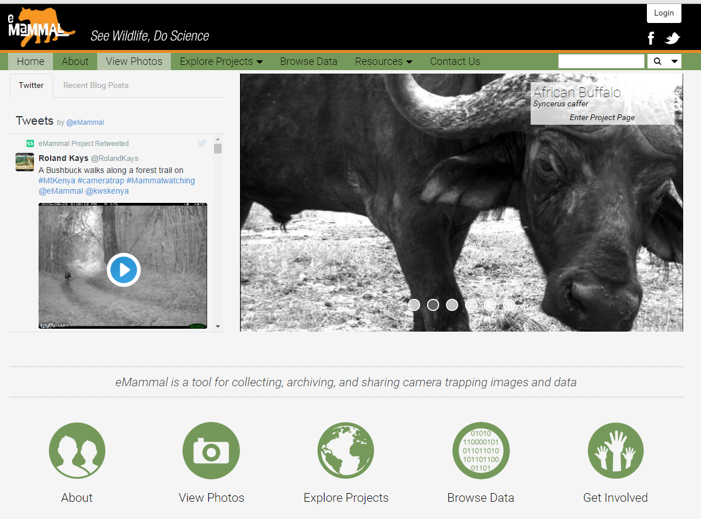
- As a class, look at a few sample images in the “Practice Images” powerpoint file provided with this lesson. Use a projector to show an image to the class, and, in small groups, have them brainstorm what data they can glean from this image. Guide them to things like species identification, weather, time, etc. The first four images in this file are designated for this purpose.

- Then, in small groups, have students carefully study images from eMammal (http://emammal.si.edu). Favorite photos from many eMammal projects can be found under the “View Photos” option either in the top bar or among the bottom icons on eMammal.

- Have each group look at a few photos. For each image, have them list the types of information/data that they find on a sheet of paper.

- As a whole class, have students contribute their ideas to a list on a white/ blackboard or large format paper. Accept all answers at first. [Actual data types include date, time, mammal images for species identification, surrounding vegetation, temperature, weather (precipitation, sunny/cloudy), moon phase. Also included in the data collected by the team placing the camera: location (latitude/longitude).]

- Ask students to think about what kinds of data they CAN’T find from the images. Some examples of data scientists often can’t get from cameras include animal behavior beyond the range of the camera, feeding habits, data that helps manage populations (birth and death rates and causes), and identification of individual animals (studies of tigers or spotted cat species can identify individuals, but most species don’t have obvious individual variation).

STEP 3: Discuss the value of camera trap images for scientific research. (10 minutes)
- Ask students to think about what science is and how data fits into its process. Ask a few students to share their thoughts and use their responses to further explain what scientific investigation is. Explain that science is the systematic exploration of the world, using observations and data to answer questions, with the goal of achieving a closer understanding of natural processes and phenomena.

- Now ask: How do careful observations differ from an experiment? How are data used in each? After students share, explain that scientific experiments follow a particular protocol that tries to determine how one variable affects another, and must use controlled conditions to determine this. However, there are other branches of science that focus on description and observation or use computer models. In all cases though, scientists are using a systematic approach to collect evidence to choose between alternative hypotheses explaining a phenomenon.

- See this video from eMammal Academy for more on this topic: https://www.youtube.com/watch?v=DMIJNbzHCkY

- Now, thinking more specifically about the camera trap images they analyzed, discuss why camera trap images might be useful for scientific study. Ask:
- What types of scientists might use these?
- How might these data be useful? (i.e., what can they tell you/what questions can they answer)
- How might these data NOT be useful? (i.e., what can’t they tell you/what questions can’t they answer)
Have students write these ideas down and keep them to reflect on in later lessons.
EXTENSIONS
- Observations and Inferences: To explore the difference between observations and inferences, have students look closely at their lists and determine if any of the information they listed is an inference or an observation. Some examples:
  - Observation: “The bear is behind a small tree.”
Inference: “The bear is hiding from the camera.”
Explanation: The inference might or might not be true; in this case it’s not possible to be sure of the bear’s behavior beyond what is directly observed.
  - Observation: “The wild boar image was taken during the daytime.”
Inference: “Wild boars are most active during the day.”
Explanation: This one image does not provide enough information to infer that wild boars are most active during the day.
  - Observation: "There are two animals, one large and one small."
Inference: "One is the mother and the other is its baby." Explanation: The information in the photo does not enable us to know that for sure.
- Camera Trap Images in a Series: Have students determine further observations that are possible with these series
of images:
“Red Fox playing Ball”: http://youtu.be/-Y-NatqY0oA
“Battling Deer”: http://youtu.be/OfivrN-wRaY
- Exploring camera traps in popular science: Have students watch the video and read the article here: https://www.washingtonpost.com/news/speaking-of-science/wp/2015/12/24/cameras-capture-never-before-seen-footage-of-wild-crows-building-tools/

Briefly discuss this example of scientific discovery using camera traps as a class. How does this relate to their answers in the final part of this activity? Would any of their answers change?

